ASSIGNMENT 1 - Submission of Intro to Web Dev

QUE-1. Explain the difference between frontend, backend, and full-stack development with suitable real-world examples.
Frontend: user interface.
Backend: server logic and database.
Full-stack: both.
Example: Amazon product page(frontend), payment system(backend).

QUE-2. Create a simple diagram showing how the client-server model works in web architecture.
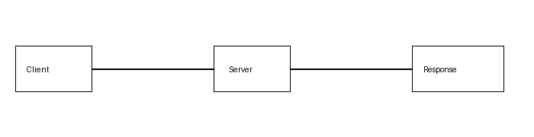

QUE-3. Describe how a browser requests and displays a web page from a web server.
Steps: URL->HTTP request->DNS->Server->HTML/CSS/JS response->Browser renders page.

QUE-4. Identify and list the tools required to set up a web development environment. Explain the purpose of each.
VS Code, Browser, Git, GitHub, Node.js/npm, Live Server.

QUE-5. Explain what a web server is and give examples of commonly used servers.
Web server hosts websites. Examples: Apache, Nginx, Microsoft IIS.

QUE-6. Define the roles of a frontend developer, backend developer, and database administrator in a project.
Frontend:UI, Backend:logic/APIs, DBA:database management.

QUE-7. Install VS Code and configure it for HTML, CSS, and JavaScript development. Take a screenshot of the setup.
Insert your own VS Code screenshot.

QUE-8. Explain the difference between static and dynamic websites. Provide an example of each.
Static=fixed pages (portfolio). Dynamic=database-driven (Amazon).

QUE-9. Research and list five web browsers. Explain how rendering engines differ between them.
Chrome-Blink, Edge-Blink, Firefox-Gecko, Safari-WebKit, Opera-Blink.

QUE-10. Draw a labeled diagram showing the basic web architecture flow — client, server, database, and APIs.
